Azure Resource Manager

Hands-on lab step-by-step

December 2017

Information in this document, including URL and other Internet Web site references, is subject to change without notice. Unless otherwise noted, the example companies, organizations, products, domain names, e-mail addresses, logos, people, places, and events depicted herein are fictitious, and no association with any real company, organization, product, domain name, e-mail address, logo, person, place or event is intended or should be inferred. Complying with all applicable copyright laws is the responsibility of the user. Without limiting the rights under copyright, no part of this document may be reproduced, stored in or introduced into a retrieval system, or transmitted in any form or by any means (electronic, mechanical, photocopying, recording, or otherwise), or for any purpose, without the express written permission of Microsoft Corporation.

Microsoft may have patents, patent applications, trademarks, copyrights, or other intellectual property rights covering subject matter in this document. Except as expressly provided in any written license agreement from Microsoft, the furnishing of this document does not give you any license to these patents, trademarks, copyrights, or other intellectual property.

The names of manufacturers, products, or URLs are provided for informational purposes only and Microsoft makes no representations and warranties, either expressed, implied, or statutory, regarding these manufacturers or the use of the products with any Microsoft technologies. The inclusion of a manufacturer or product does not imply endorsement of Microsoft of the manufacturer or product. Links may be provided to third party sites. Such sites are not under the control of Microsoft and Microsoft is not responsible for the contents of any linked site or any link contained in a linked site, or any changes or updates to such sites. Microsoft is not responsible for webcasting or any other form of transmission received from any linked site. Microsoft is providing these links to you only as a convenience, and the inclusion of any link does not imply endorsement of Microsoft of the site or the products contained therein.

© 2017 Microsoft Corporation. All rights reserved.

Microsoft and the trademarks listed at <https://www.microsoft.com/en-us/legal/intellectualproperty/Trademarks/Usage/General.aspx> are trademarks of the Microsoft group of companies. All other trademarks are property of their respective owners.

Contents

Azure Resource Manager hands-on lab step-by-step 1

Abstract and learning objectives 1

Overview 1

Requirements 1

Before the hands-on lab (HOL) 2

Task 1: Create a virtual machine for your lab environment 2

Task 2: Connect to the VM and download the student files 3

Task 3: Validate connectivity to Azure 8

Exercise 1: Configure Automation Account 9

Task1: Create Automation Account 9

Task 2: Upload DSC Configurations into Automation Account 10

Task 3: Add an Azure Automation credential 12

Exercise 2: Define the network foundation 13

Task 1: Deploy a virtual network with a template 13

Exercise 3: Extend with Compute 19

Task 1: Add an Azure storage account 19

Task 2: Add a virtual machine and configure as a web server 20

Task 3: Add a Windows virtual machine for the database server 25

Task 4: Deploy your updated template to Azure 33

Exercise 4: Lock down the environment 39

Task 1: Restrict traffic to the web server 39

Task 2: Update the network security group to allow Windows Remote Desktop 41

Exercise 5: Scale out the deployment 43

Task 1: Parameterize and scale out the environment 43

After the hands-on lab 51

Task 1: Delete the resource groups created 51

Azure Resource Manager hands-on lab step-by-step

## Abstract and learning objectives

In this lab, attendees will learn how to author an Azure Resource Manager (ARM) template that can be used to deploy infrastructure such as virtual machine, storage, and networking. This lab will also teach the attendees how to deploy virtual machines that are automatically configured by the Azure Automation Desired State Configuration (DSC) service.

* How to author and deploy an ARM template
* How to perform configuration management with Azure Automation DSC

## Overview

Contoso has asked you to define an Azure Resource Manager (ARM) template that can deploy their application CloudShop and its associated database using Azure Virtual Machines.

## Requirements

1. Azure Subscription
2. Understanding of Azure Infrastructure as a Service components
3. Familiarity with JavaScript Object Notation (JSON)
4. Familiarity with PowerShell

## Before the hands-on lab (HOL)

Duration: 15 minutes

Prior to attending the lab, follow the instructions below to create a lab environment using an Azure Virtual Machine and download the needed files for the lab exercise.

#### Task 1: Create a virtual machine for your lab environment

1. Launch a browser using incognite or in-private mode, and navigate to <https://portal.azure.com>. Once prompted, login with your Microsoft Azure credentials. If prompted, choose whether your account is an organization account or just a Microsoft Account.
2. Click on +NEW, and in the search box, type in Visual Studio Community 2017 on Windows Server 2016 (x64), and press enter. Click the Visual Studio Community 2017 image running on Windows Server 2016 and with the latest update.
3. In the returned search results, click the image name.

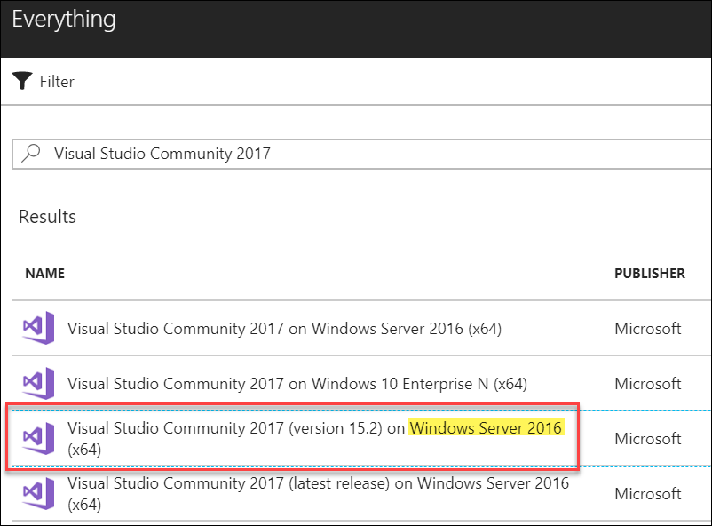

1. In the Marketplace solution blade, click **Create**.
2. Set the following configuration on the Basics tab, and click **OK**.
   * Name: **LABVM**
   * VM disk type: **SSD**
   * User name: **demouser**
   * Password: **demo@pass123**
   * Subscription: **If you have multiple subscriptions choose the subscription to execute your labs in.**
   * Resource Group: **OPSLABRG**
   * Location: **Choose the closest Azure region to you.**
3. Choose the **DS1_V2 Standard** instance size on the Size blade.
4. Accept the remaining default values on the Settings blade, and click **OK**. On the Summary page, click **OK**. The deployment should begin provisioning. It may take more than 10 minutes for the virtual machine to complete provisioning.

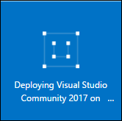

#### Task 2: Connect to the VM and download the student files

1. Move back to the Portal page on your local machine, and wait for **LABVM** to show the Status of **Running**. Click **Connect** to establish a new Remote Desktop Session.

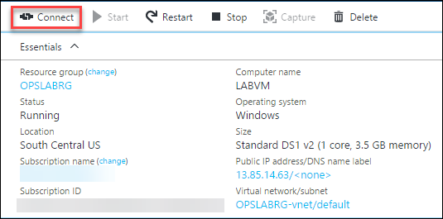

1. Depending on your remote desktop protocol client and browser configuration, you will either be prompted to open an RDP file, or you will need to download it and then open it separately to connect. You may also be required to click, **Use a different account**.

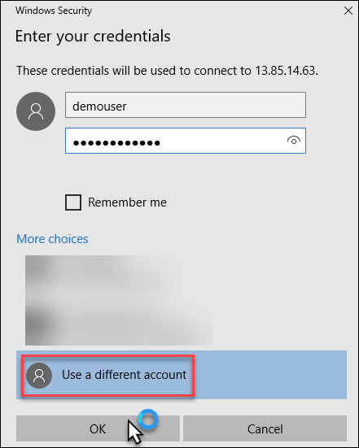

1. Login with the credentials specified during creation:
   1. User: **demouser**
   2. Password: **demo@pass123**
2. You will be presented with a Remote Desktop Connection warning because of a certificate trust issue. Click, **Don’t ask me again for connections to this computer** followed by clicking **Yes** to continue with the connection.

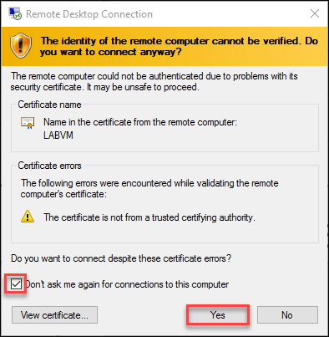

1. When logging on for the first time, you will see a prompt on the right asking about network discovery. Click **No**.

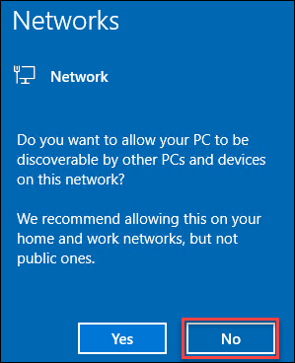

1. Notice the Server Manager opens by default. On the left, click **Local Server**.

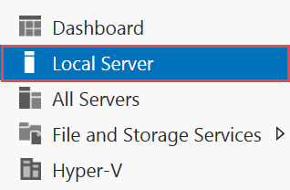

1. On the right side of the pane, click **On** by **IE Enhanced Security Configuration**.

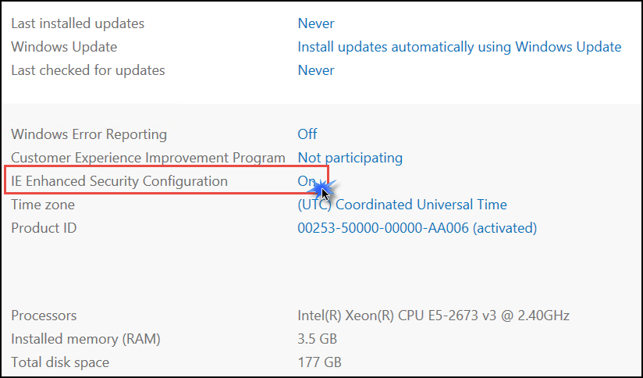

1. Change to **Off** for Administrators, and click **OK**.

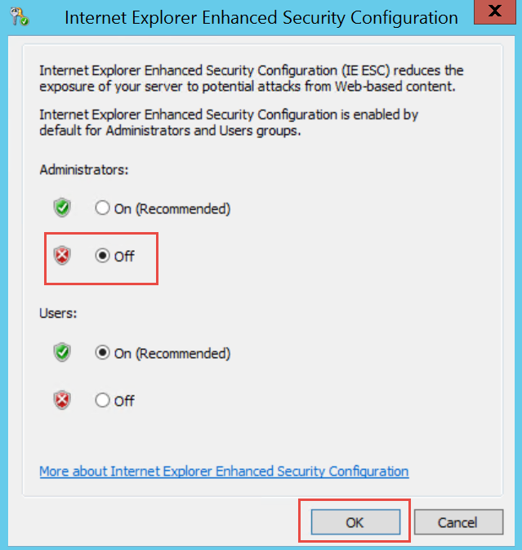

1. In the lower left corner, click Internet Explorer to open it. On first use, you will be prompted about security settings. Accept the defaults by clicking **OK**.

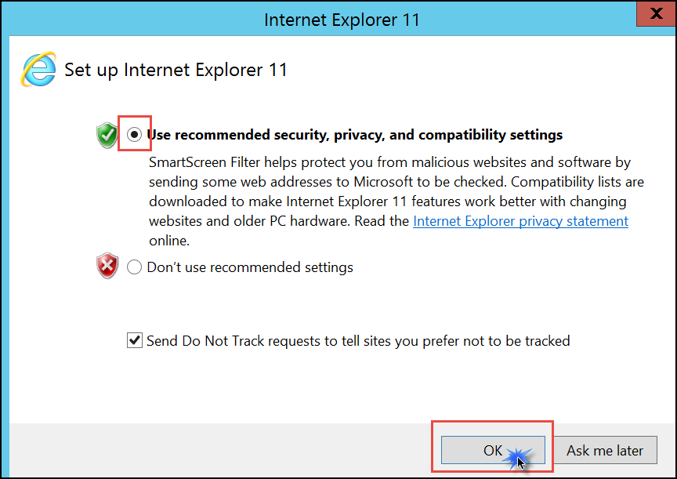

1. If prompted, click **Don’t show this again** regarding protected mode.
2. To download the exercise files for the lab, paste this URL into the browser.

<https://cloudworkshop.blob.core.windows.net/arm-hackathon/ARM_Hackathon_Guide_Student_Files.zip>

1. You will be prompted about what you want to do with the file. Select **Save**.

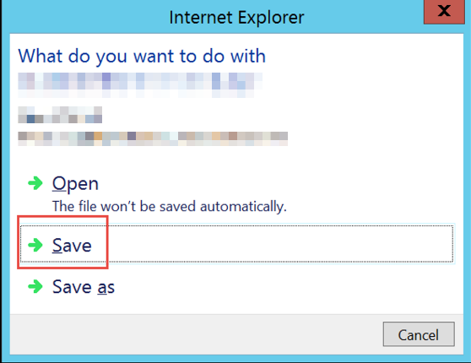

1. Download progress is shown at the bottom of the browser window. When the download is complete, click **Open folder**.



1. The **Downloads** folder will open. ***Right-click*** the zip file, and click **Extract All**.In the **Extract Compressed (Zipped) Folders** window, enter **C:\Hackathon** in the **Files will be extracted to this folder** dialog. Click the **Extract** button.

#### Task 3: Validate connectivity to Azure

1. Within the virtual machine, launch **Visual Studio 2017**, and validate you can login with your Microsoft Account when prompted.

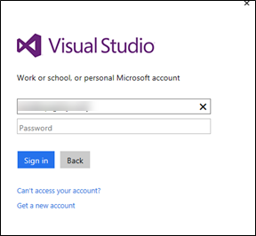

1. Validate connectivity to your Azure subscription. Launch **Visual Studio**, open **Server Explorer** from the View menu, and ensure you can connect to your Azure subscription.

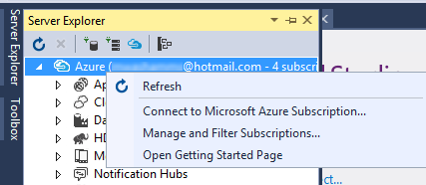

You should follow all steps provided *before* attending the hands-on lab.

## Exercise 1: Configure Automation Account

Duration: 15 minutes

In this exercise, you will create and configure an Azure Automation Account in the Azure portal before configuring and deploying the resources of your ARM template.

#### Task1: Create Automation Account

1. Browse to the Azure portal and authenticate at <https://portal.azure.com/>
2. Click **+New** and type **Automation** in the search box. Choose **Automation** from the results.

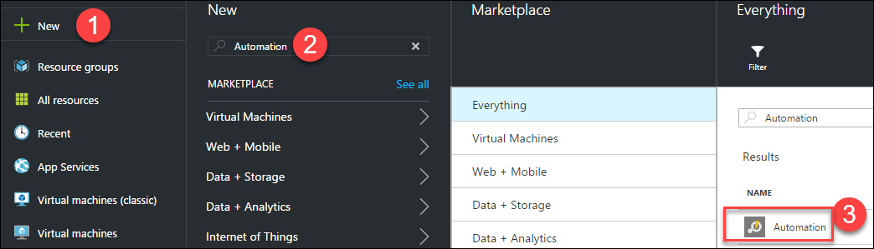

1. Click **Create** on the Automation blade to display the **Add Automation Account** blade. Specify the following information, and click **Create**.  
     
   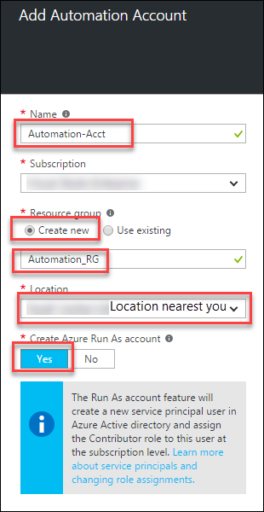

#### Task 2: Upload DSC Configurations into Automation Account

1. Click **Resource groups > Automation_RG > Automation-Acct**, and click the **DSC Configurations** menu.

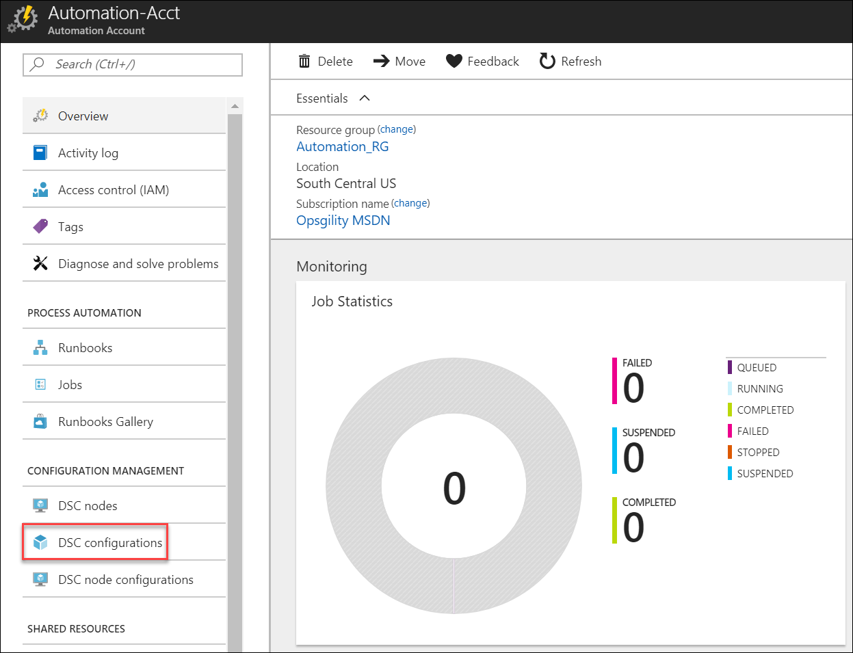

1. Click **+Add a configuration** to upload **C:\Hackathon\CloudShopSQL.ps1** and **C:\Hackathon\CloudShopWeb.ps1.**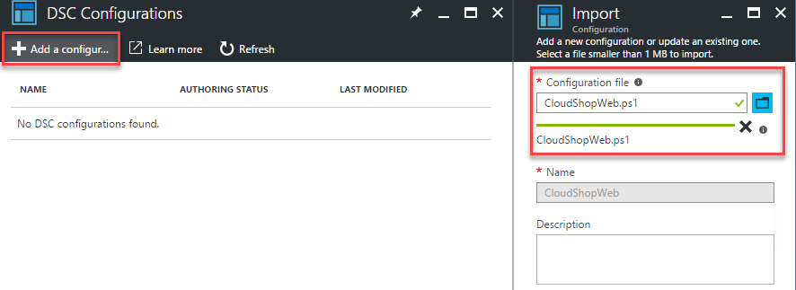
2. After importing the .ps1 files, click the **CloudShopSQL** DSC Configuration and click **Compile** on the toolbar (click **OK** on the Start Compilation Job blade). Do the same for **CloudShopWeb.**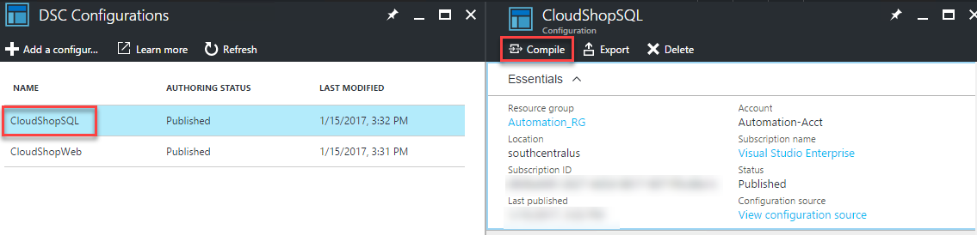

#### Task 3: Add an Azure Automation credential

1. The CloudShopSQL DSC configuration requires a credential object to access the local administrator account on the virtual machine. Within the Azure Automation DSC configuration click **Credentials** in the **SHARED RESOURCES** section.

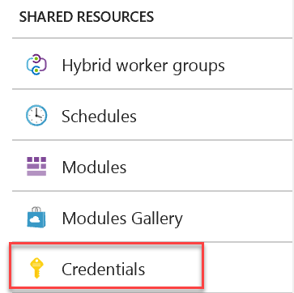

1. Click the **Add a credential** button.



1. Specify the following properties and confirm creation to continue.
   1. **Name**: SQLLocalAdmin
   2. **User Name**: demouser
   3. **Password & Confirm**: demo@pass123

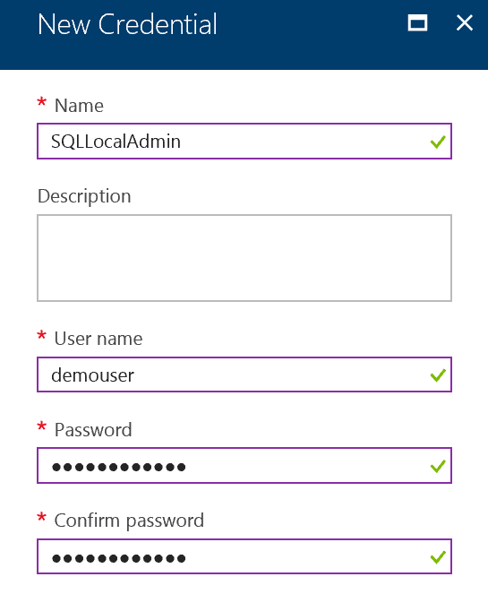

Important: It is important to use the exact name for the credential, because one of the scripts you upload in the next step references the name directly.

## Exercise 2: Define the network foundation

Duration: 15 minutes

Your first ARM template task is to create a virtual network template using Visual Studio and deploy it to your Azure account.

#### Task 1: Deploy a virtual network with a template

1. Open Visual Studio. The shortcut should be available on the desktop, and if it is not, click the Windows icon in the bottom left corner, and type in Visual Studio. You should see the start icon.
2. Choose **File**, and **New Project**. Then, choose **Cloud** followed by **Azure Resource Group**.
3. Name the project **ARMHackathon**,specify **C:\Hackathon** for the location, and click **OK**.

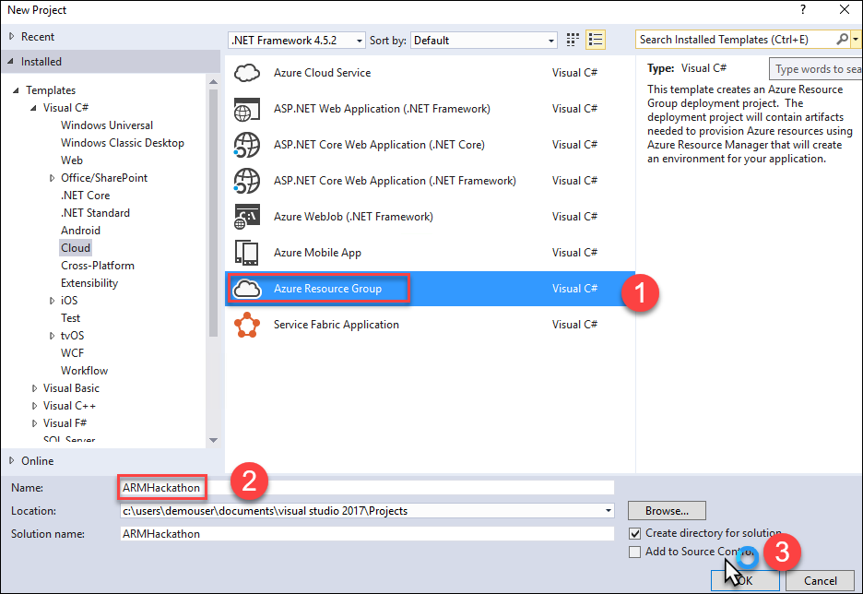

1. On the Select Azure Template dialog box, choose **Blank Template**, and click **OK**.

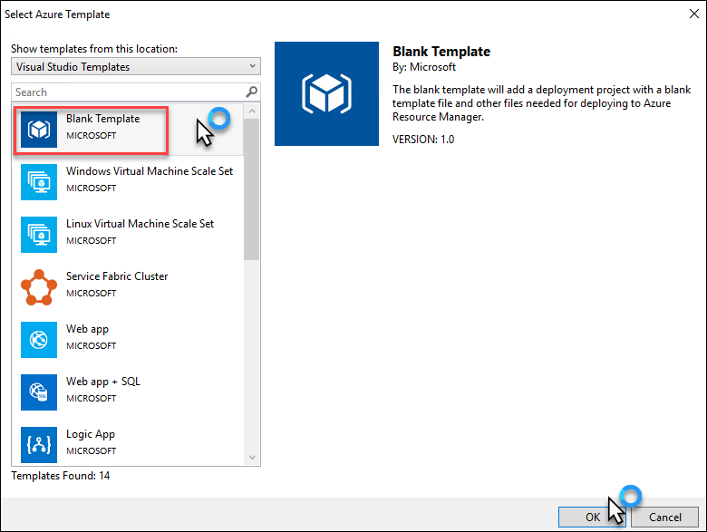

1. In the **Solution Explorer**, open the **azuredeploy.json** under the solution.

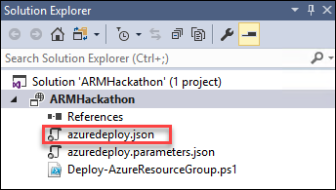

1. The file should contain four different sections: parameters, variables, resources, and outputs. On the left side, a new window called **JSON Outline** should have been opened as well.

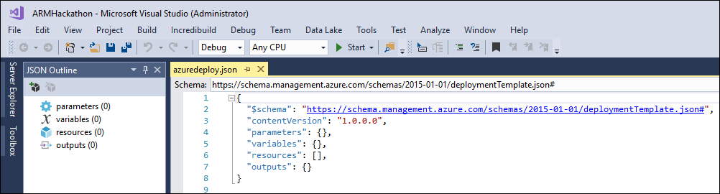

NOTE: If this was not the case, go to the View menu, select Other Windows, and choose JSON Outline. The window should look like the following image.

1. On the **JSON Outline** window, click **Add Resource** in the upper-left corner or right-click the **resources**, and choose **Add New Resource**.



1. On the **Add Resource** dialog box, choose **Virtual Network**, enter **hackathonVnet** in the **Name** field, and click **Add**.

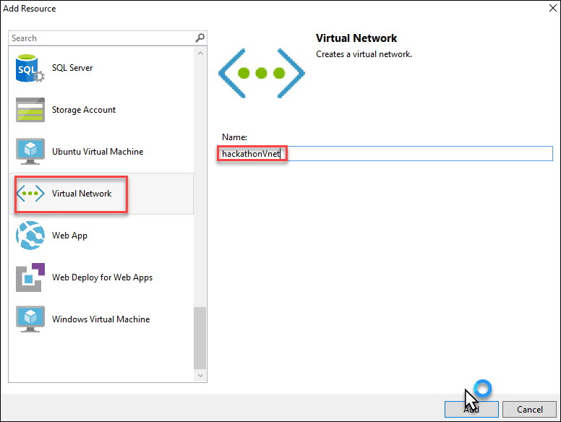

1. Go to the **azuredeploy.json** file, and inspect its content. Review the **variables** section. It should look like the following file.

"variables": {

"hackathonVnetPrefix": "10.0.0.0/16",

"hackathonVnetSubnet1Name": "Subnet-1",

"hackathonVnetSubnet1Prefix": "10.0.0.0/24",

"hackathonVnetSubnet2Name": "Subnet-2",

"hackathonVnetSubnet2Prefix": "10.0.1.0/24"

},

1. Change the name of **Subnet-1** to **FrontEndNet** as well as the name of **Subnet-2** to **DatabaseNet**.

"hackathonVnetSubnet1Name": "FrontEndNet",

"hackathonVnetSubnet2Name": "DatabaseNet",

1. Deploy the template by **right-clicking** the **ARMHackathon** project and choosing **Deploy** **>** **New**.

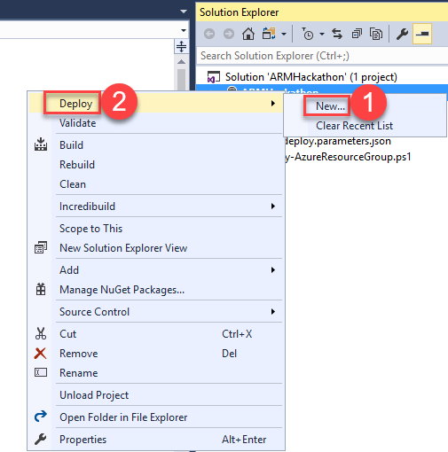

1. If you did not sign in to your Microsoft Azure account already, you will be asked to do so now.
2. Fill in the email address associated with the Azure account, and click **Continue**.

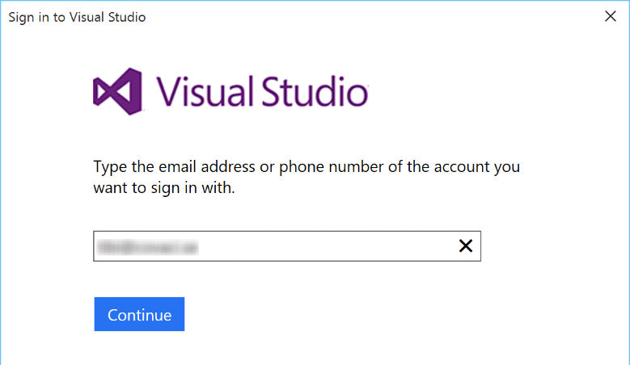

1. You might have to choose between a work/school account and a Microsoft account. Microsoft account refers to a Live ID account. Depending on what kind of account you have, you should choose one or the other.
2. Enter your password, and click **Sign In**.

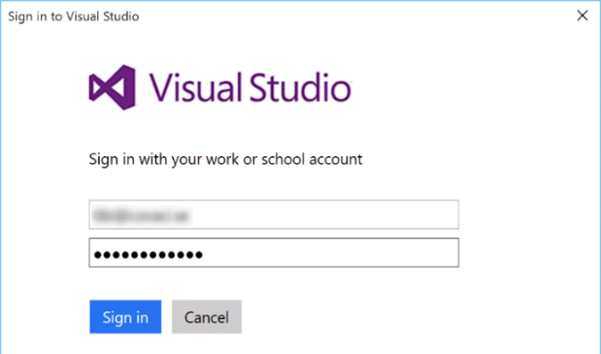

1. If you have several subscriptions, choose the one that you want your VNet to be deployed to, and on the Resource group, choose **Create New**.

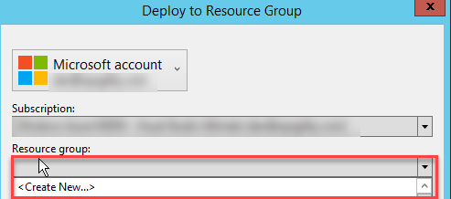

1. On the Create Resource Group dialog box, accept the default value for the name. For the location, choose the **closest location to you**, and click **Create**.

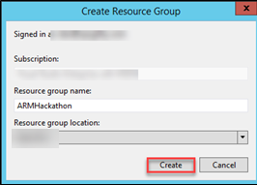

1. When you are back on the Deploy to Resource Group dialog box, click **Deploy**. After about a minute, your virtual network will be deployed to Azure.

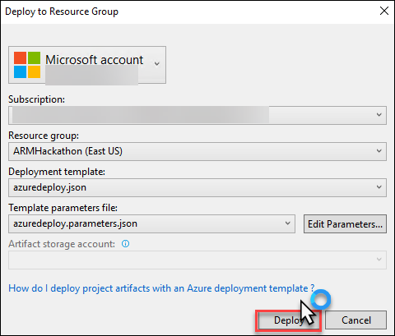

1. View the created resource group and virtual network in the Azure Management Portal by clicking **Resource Groups** and clicking the **ARMHackathon**.



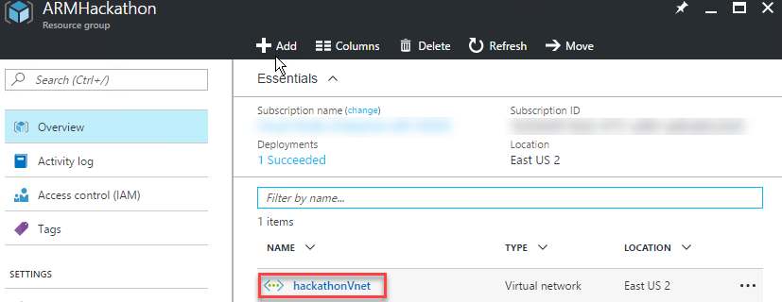

**NOTE**: If the resource group was created but the virtual network was not, redeploy the template once more from Visual Studio.

You should see an indication of a successful deployment in the **Output** screen.

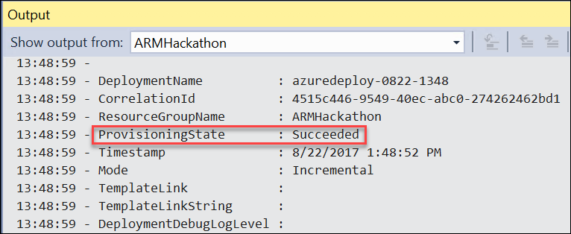

1. To verify the new network was created, within the Azure portal, navigate to **Virtual Networks**. Your new network should be listed there.

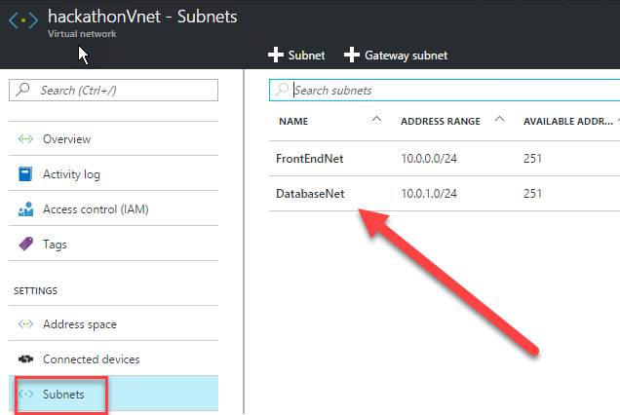

## Exercise 3: Extend with Compute

Duration: 60 minutes

In this exercise, you will continue the work you started in the previous task by creating a storage account and adding virtual machines for the web application and database followed by configuring the machines for the roles.

#### Task 1: Add an Azure storage account

1. On the **JSON Outline** window, click **Add Resource** in the upper-left corner, or right-click the **resources** and choose **Add New Resource**.



1. Add a new **Storage Account** resource to the template named ***hackstorage***.

Note: The template generated in the Azure SDK appends a unique value (13 characters in length) to the storage account name. Ensure the name specified is 11 characters or less in length.

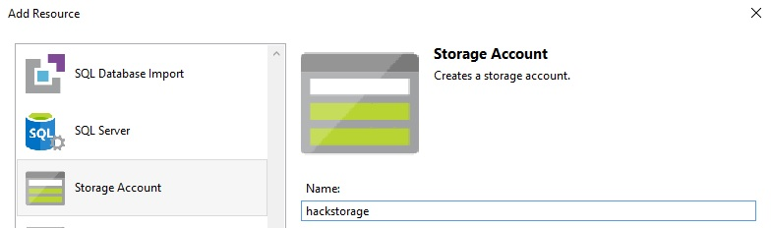

1. In the JSON Outline, locate the parameter named **hackstorageType**.



1. Update the Storage code to use **Premium_LRS** as the defaultValue by changing it from Standard_LRS to Premium_LRS.

Before the change:

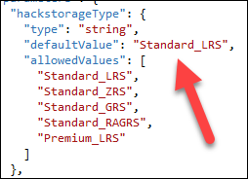

After the change:

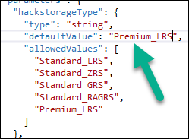

#### Task 2: Add a virtual machine and configure as a web server

1. Add a new **Windows Virtual Machine** called **hackathonVM**, and choose ***hackstorage*** as the Storage Account and **FrontEndNet** subnet as the Virtual network/subnet. The **FrontEndNet** is the value of **hackathonVnetSubnet1Name** variable.

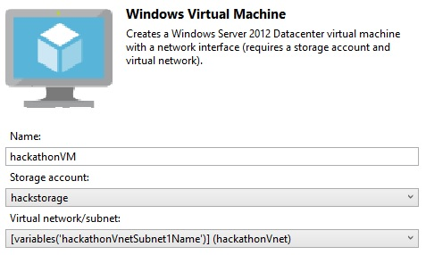

1. Locate the Parameter **hackathonVMWindowsOSVersion**.



1. Replace the code between the start { and stop } brackets with the updated code below to allow for the use of Windows Server 2016 Offerings. Ensure you do not remove either of the { } brackets in the process.

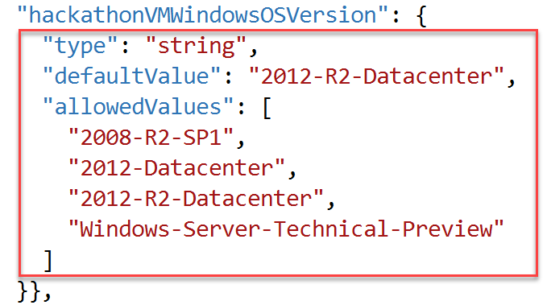

Replace the code block with the code below:

"type": "string",

"defaultValue": "2016-Datacenter",

"allowedValues": [

"2016-Datacenter"

]

1. A **Network Interface** named ***hackathonVMNic*** was automatically added to the configuration when the virtual machine resource was added to connect the virtual machine to the virtual network. Add a Public IP address called ***hackathonPublicIP*** to the **hackathonVMNic**. This will allow you to connect to the machine using remote desktop client or to access the web server.

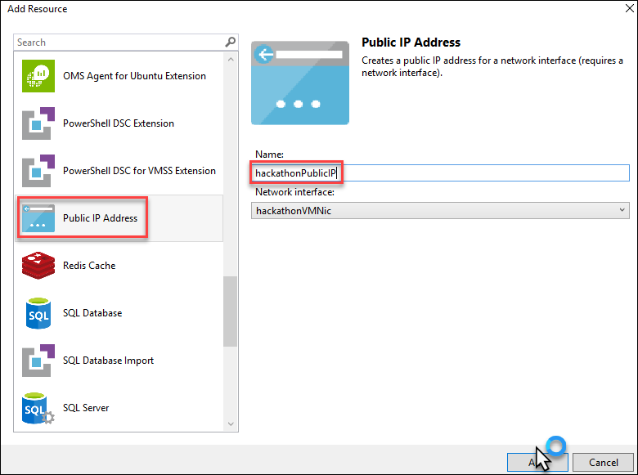

1. Next you will add the PowerShell DSC Extension to the **azuredeploy.json** file. This will register the VM with Azure Automation DSC Extension.

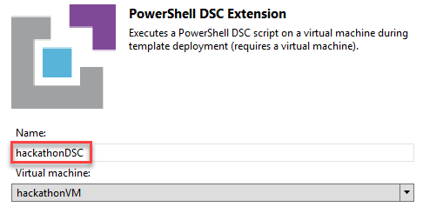

1. Change the Type Handler from 2.9 to **2.19**, and make sure that autoUpgradeMinorVersion is **false**.

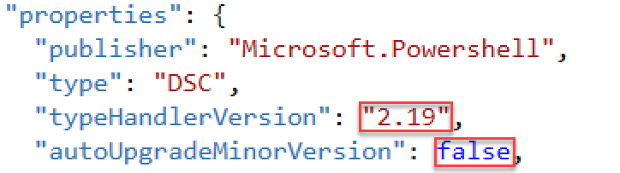

Note: This is due to a bug in PowerShell DSC at the time of this writing. It may be resolved by now.

1. Find the settings code within the PowerShell DSC section you just added, and replace it with this code (make sure you do not remove the protectedSettings block):

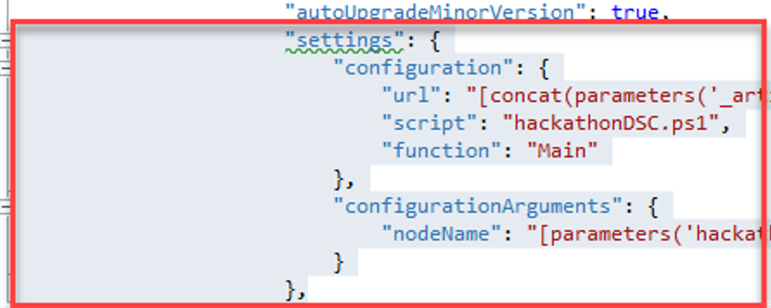

"settings": {

"modulesUrl": "https://cloudworkshop.blob.core.windows.net/arm-hackathon/RegistrationMetaConfigV2.zip",

"configurationFunction": "RegistrationMetaConfigV2.ps1\\RegistrationMetaConfigV2",

"Properties": [

{

"Name": "RegistrationKey",

"Value": {

"UserName": "PLACEHOLDER_DONOTUSE",

"Password": "PrivateSettingsRef:registrationKeyPrivate"

},

"TypeName": "System.Management.Automation.PSCredential"

},

{

"Name": "RegistrationUrl",

"Value": "[parameters('registrationUrl')]",

"TypeName": "System.String"

},

{

"Name": "NodeConfigurationName",

"Value": "[parameters('nodeConfigurationName')]",

"TypeName": "System.String"

},

{

"Name": "ConfigurationMode",

"Value": "[parameters('configurationMode')]",

"TypeName": "System.String"

},

{

"Name": "ConfigurationModeFrequencyMins",

"Value": "[parameters('configurationModeFrequencyMins')]",

"TypeName": "System.Int32"

},

{

"Name": "RefreshFrequencyMins",

"Value": "[parameters('refreshFrequencyMins')]",

"TypeName": "System.Int32"

},

{

"Name": "RebootNodeIfNeeded",

"Value": "[parameters('rebootNodeIfNeeded')]",

"TypeName": "System.Boolean"

},

{

"Name": "ActionAfterReboot",

"Value": "[parameters('actionAfterReboot')]",

"TypeName": "System.String"

},

{

"Name": "AllowModuleOverwrite",

"Value": "[parameters('allowModuleOverwrite')]",

"TypeName": "System.Boolean"

},

{

"Name": "Timestamp",

"Value": "[parameters('timestamp')]",

"TypeName": "System.String"

}

]

},

1. Next in the protectedSettings section, delete the “configurationUrlSasToken” line; replacing it with this code.

"Items": {

"registrationKeyPrivate": "[parameters('registrationKey')]"

}

Before:



After:

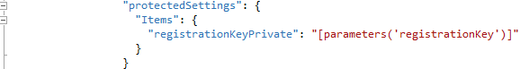

1. You will now append the following parameters to your json template (*after the* ***hackathonPublicIPDnsName*** *parameter*).  
     
   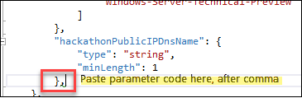

"registrationKey": {

"type": "string",

"metadata": {

"description": "Registration key of Automation account"

}

},

"registrationUrl": {

"type": "string",

"metadata": {

"description": "Registration URL of Automation account"

}

},

"nodeConfigurationName": {

"type": "string",

"metadata": {

"description": "Name of configuration to apply"

}

},

"rebootNodeIfNeeded": {

"type": "bool",

"metadata": {

"description": "Reboot if needed"

}

},

"allowModuleOverwrite": {

"type": "bool",

"metadata": {

"description": "Allow Module Overwrite"

}

},

"configurationMode": {

"type": "string",

"defaultValue": "ApplyAndMonitor",

"allowedValues": [

"ApplyAndMonitor",

"ApplyOnly",

"ApplyandAutoCorrect"

],

"metadata": {

"description": "Configuration Mode"

}

},

"configurationModeFrequencyMins": {

"type": "int",

"metadata": {

"description": "Allow Module Overwrite"

}

},

"refreshFrequencyMins": {

"type": "int",

"metadata": {

"description": "Refresh frequency in minutes"

}

},

"actionAfterReboot": {

"type": "string",

"defaultValue": "ContinueConfiguration",

"allowedValues": [

"ContinueConfiguration",

"StopConfiguration"

],

"metadata": {

"description": "Action after reboot"

}

},

"timestamp": {

"type": "string",

"metadata": {

"description": "Time stamp MM/dd/YYYY H:mm:ss"

}

}

1. In the “**variables**” section, change the value of hackathonVMVmSize" to "Standard_DS1_v2.”



1. Save your changes to the **azuredeploy.json** template file.

#### Task 3: Add a Windows virtual machine for the database server

1. Add another virtual machine to the template by clicking **Add Resource** and next, selecting **Windows Virtual Machine**.

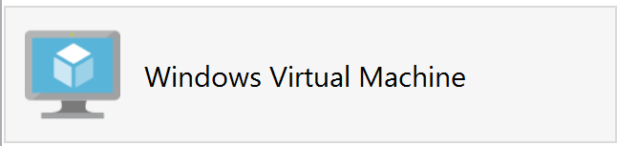

1. Name this virtual machine resource **hackathonSqlVM**, and reference the parameters **hackStorage** and **hackathonVnetSubnet2Name** respectively.

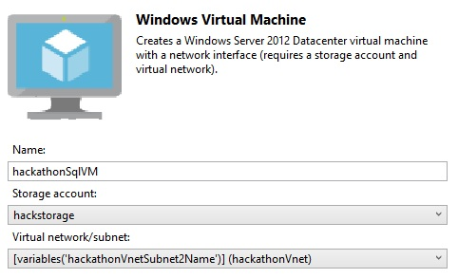

1. Navigate to the **variables** section, and find the following variables:



1. Modify the following **hackathonSqlVMImagePublisher** and **hackathonSqlVMImageOffer** variables to the following SQL Server image values:

"hackathonSqlVMImagePublisher": "MicrosoftSQLServer",

"hackathonSqlVMImageOffer": "SQL2016SP1-WS2016",

1. Find the **hackathonSqlVMWindowsOSVersion** parameter.



1. Replace the **hackathonSqlVMWindowsOSVersion** parameter with the following:

"hackathonSqlVMSKU": {

"type": "string",

"defaultValue": "Web",

"allowedValues": [

"Web",

"Standard",

"Enterprise"

]

}

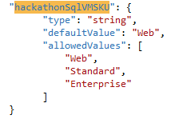

1. Click the **hackathonSqlVM** resource to move to its properties.

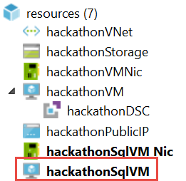

1. Update the **SKU** property to point to the new parameter: **hackathonSqlVMSKU**.

"sku": "[parameters('hackathonSqlVMSKU')]",

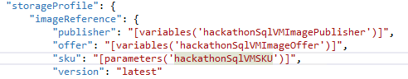

1. Navigate to the **parameters** section of the template, and add a new parameter called **vmSizeSQL** to define the size of the virtual machine.

**Tip:** Do not forget the preceding comma.

"vmSizeSql": {

"type": "string",

"defaultValue": "Standard_DS1_v2",

"allowedValues": [

"Standard_DS1_v2",

"Standard_DS2_v2",

"Standard_DS3_v2",

"Standard_DS4_v2",

"Standard_D5_v2"

]

}

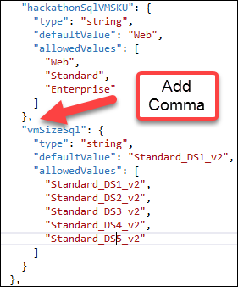

1. Navigate to the **resources** section for the **hackathonSqlVM**. Find the **hardwareProfile** section, and replace the reference to the **vmSize** variable to a reference to the new **vmSizeSql** parameter:

"vmSize": "[parameters('vmSizeSql')]"

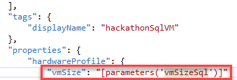

1. Next, define two variables that build the paths for two data disks for the **hackathonSqlVM** by first adding the storage paths as variables in the variables section of the template.

"dataDisk1VhdName": "[concat('http://',variables('hackStorageName'),'.blob.core.windows.net/','vhds','/','dataDisk1.vhd')]",

"dataDisk2VhdName": "[concat('http://',variables('hackStorageName'),'.blob.core.windows.net/','vhds','/','dataDisk2.vhd')]"

NOTE: Do not forget to add a comma after the last variable first followed by hitting enter. This will start a new line where you can paste.

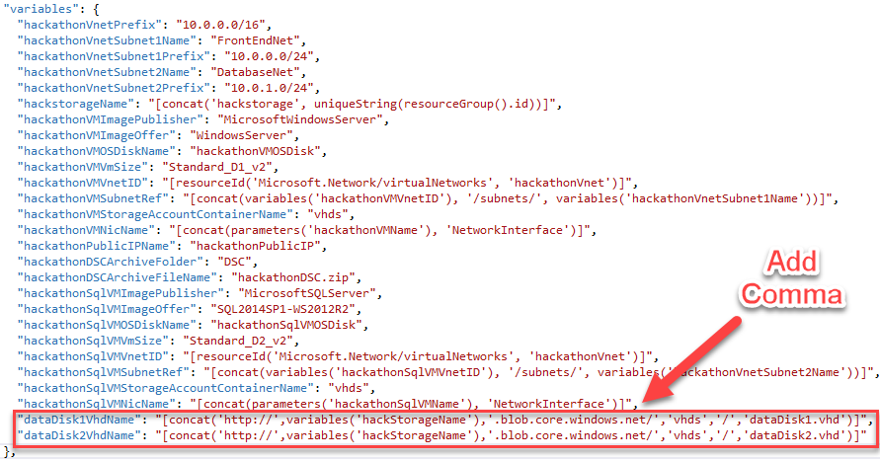

1. To deploy two 1TB disks, add the following section to the properties, storage profile section of the **hackathonSqlVM** (right after osDisk).

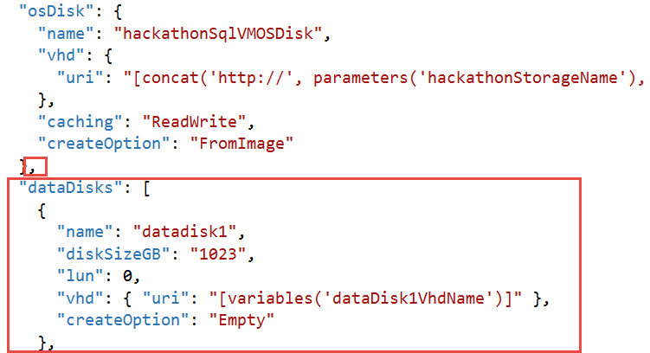

Tip: Do not forget to add a comma at the end of the osDisk section.

"dataDisks": [

{

"name": "datadisk1",

"diskSizeGB": "1023",

"lun": 0,

"vhd": { "uri": "[variables('dataDisk1VhdName')]" },

"createOption": "Empty"

},

{

"name": "datadisk2",

"diskSizeGB": "1023",

"lun": 1,

"vhd": {"uri": "[variables('dataDisk2VhdName')]"},

"createOption": "Empty"

}]

1. Next you will add the PowerShell DSC Extension named **hackathonDSCSQL** to the **azuredeploy.json** file for the SQL VM. This will register the VM with Azure Automation DSC Extension.

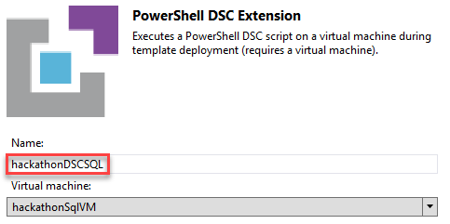

1. Create a new parameter that will be different for the SQL VM. In the **parameters** section, add the following code immediately after the existing **nodeConfigurationName** parameter.

"sqlnodeConfigurationName": {

"type": "string",

"metadata": {

"description": "Name of configuration to SQL"

}

},

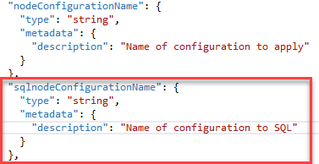

1. Save your changes to the **azuredeploy.json** template file.
2. Navigate to the hackathonDscSQL resource.

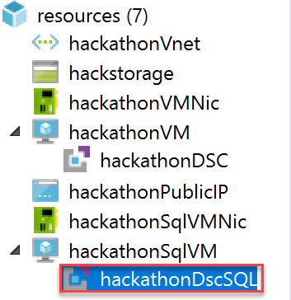

1. Change the Type Handler from **2.9 to 2.19**, and make sure that **autoUpgradeMinorVersion** is false.



Note: This is due to a bug in PowerShell DSC at the time of this writing. It may be resolved by now.

1. Find the settings code within the PowerShell DSC section you just added, and replace it with this code:

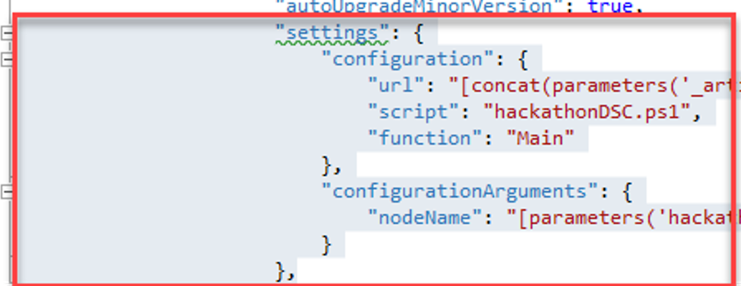

"settings": {

"modulesUrl": "https://cloudworkshop.blob.core.windows.net/arm-hackathon/RegistrationMetaConfigV2.zip",

"configurationFunction": "RegistrationMetaConfigV2.ps1\\RegistrationMetaConfigV2",

"Properties": [

{

"Name": "RegistrationKey",

"Value": {

"UserName": "PLACEHOLDER_DONOTUSE",

"Password": "PrivateSettingsRef:registrationKeyPrivate"

},

"TypeName": "System.Management.Automation.PSCredential"

},

{

"Name": "RegistrationUrl",

"Value": "[parameters('registrationUrl')]",

"TypeName": "System.String"

},

{

"Name": "NodeConfigurationName",

"Value": "[parameters('sqlnodeConfigurationName')]",

"TypeName": "System.String"

},

{

"Name": "ConfigurationMode",

"Value": "[parameters('configurationMode')]",

"TypeName": "System.String"

},

{

"Name": "ConfigurationModeFrequencyMins",

"Value": "[parameters('configurationModeFrequencyMins')]",

"TypeName": "System.Int32"

},

{

"Name": "RefreshFrequencyMins",

"Value": "[parameters('refreshFrequencyMins')]",

"TypeName": "System.Int32"

},

{

"Name": "RebootNodeIfNeeded",

"Value": "[parameters('rebootNodeIfNeeded')]",

"TypeName": "System.Boolean"

},

{

"Name": "ActionAfterReboot",

"Value": "[parameters('actionAfterReboot')]",

"TypeName": "System.String"

},

{

"Name": "AllowModuleOverwrite",

"Value": "[parameters('allowModuleOverwrite')]",

"TypeName": "System.Boolean"

},

{

"Name": "Timestamp",

"Value": "[parameters('timestamp')]",

"TypeName": "System.String"

}

]

},

1. Next, in the **protectedSettings** section, delete the “**configurationUrlSasToken**” line; replacing it with this code.

"Items": {

"registrationKeyPrivate": "[parameters('registrationKey')]"

}

Before:



After:



1. Save your changes to the **azuredeploy.json** template file.

#### Task 4: Deploy your updated template to Azure

1. Before deploying your updated template, you should take note of your Automation key and registration URL. In the Azure portal, click **Resource groups > Automation_RG > Automation-Acct**. Then, in the Account Settings area, click the **Keys** icon.

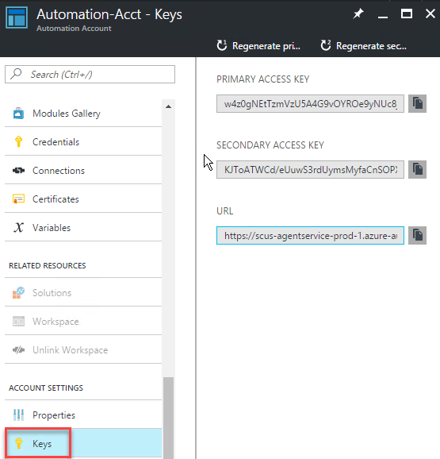

1. The information you will need to deploy your template is on the **Manage Keys** blade to the right. When doing the deployment from within Visual Studio, a Key needs to be provided. The **Primary Access Key** can be copied to the clipboard by clicking the button next to the Key on this blade.

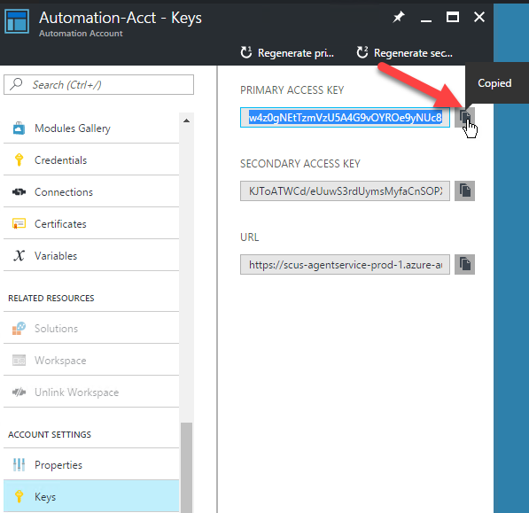

1. Using this same process, the **URL** can also be copied to use with Visual Studio.

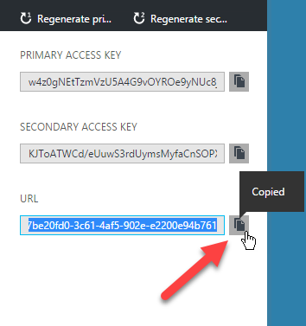

1. You will also need the name of your Node Configurations you uploaded using the portal during Exercise 1. To find these, click the DSC Configuration tile on the Azure Automation Blade. Then, click the name of each to find the Node Name.

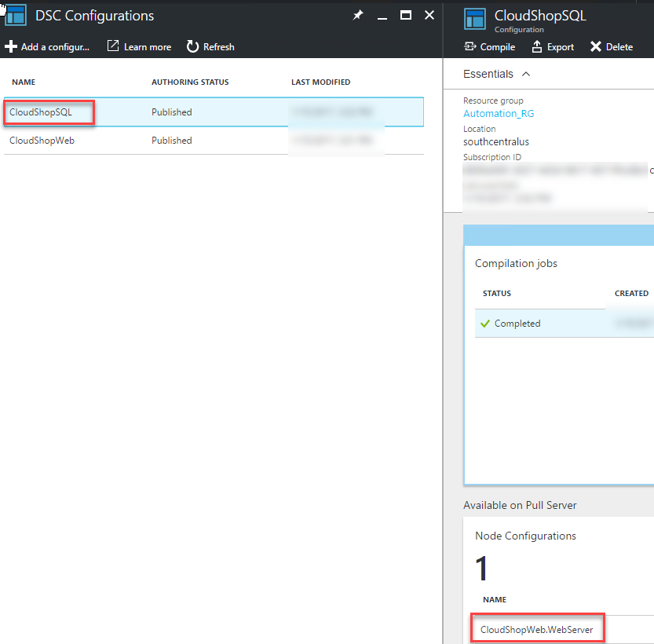

1. Within Visual Studio, create a new deployment (*specify the same Resource group as before ARMHackathon)*.   
   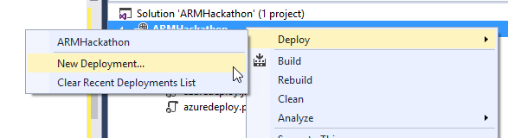
2. On the **Deploy to Resource Group** dialog box, click **Edit Parameters**, and populate the empty values.  
   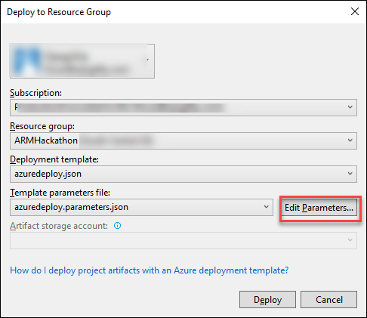

* hackathonVMName: **armweb**
* hackathonVMAdminUserName: **demouser**
* hackathonVMAdminPassword: **demo@pass123**
* hackathonPublicIPDnsName: **Choose a unique looking DNS name (must be lowercase)**
* registrationKey: **Automation account key**
* registrationUrl: **Automation registration URL**
* nodeConfigurationName: **CloudShopWeb.WebServer**
* sqlnodeConfigurationName: **CloudShopSQL.SQLSERVER**
* rebootNodeIfNeeded: **True**
* allowModuleOverwrite: **True**
* configurationMode: **ApplyAndMonitor**
* configurationModeFrequencyMins: **15**
* refreshFrequencyMins: **30**
* actionAfterReboot: ContinueConfiguration
* timestamp: **<enter current value in format like screenshot below>**
* _artifactsLocation: **<Auto-generated>**
* _artifactsLocationSasToken: **<Auto-generated>**
* hackathonSQLVMName: **armsql**
* hackathonVMSQLAdminUserName: **demouser**
* hackathonVMSQLAdminPassword: **demo@pass123**
* hackathonVMSQLSKU: **Web**
* vmsizeSQL: **Standard_DS3_v2**
* **Check: Save passwords as plain text in the parameters file**

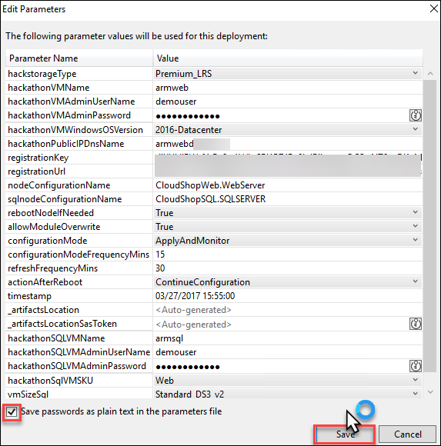

Note: The deployment may take 20 to 30 minutes to complete.

Extension Troubleshooting tip: If you make a mistake with either of the Azure DSC extensions and need to redeploy, open the virtual machine in the portal. Under all settings, click extensions, and remove the failed extension before deploying. Then, in your Automation Account, under the DSC Nodes, unregister the node.

NOTE: The DSC configuration may take time to apply following the successful template deployment. Monitor this in the DSC Nodes section in the Automation Account properties. Wait to proceed until both nodes show as compliant.

1. Launch the **Azure Management Portal** <http://portal.azure.com>,and navigate to the resource group you deployed to. Click the **virtual machine** for the web server. Then, click the **Public IP**.

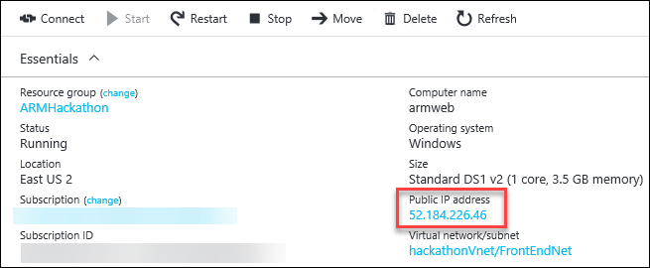

1. Copy the **IP address**, and navigate to it in the browser.

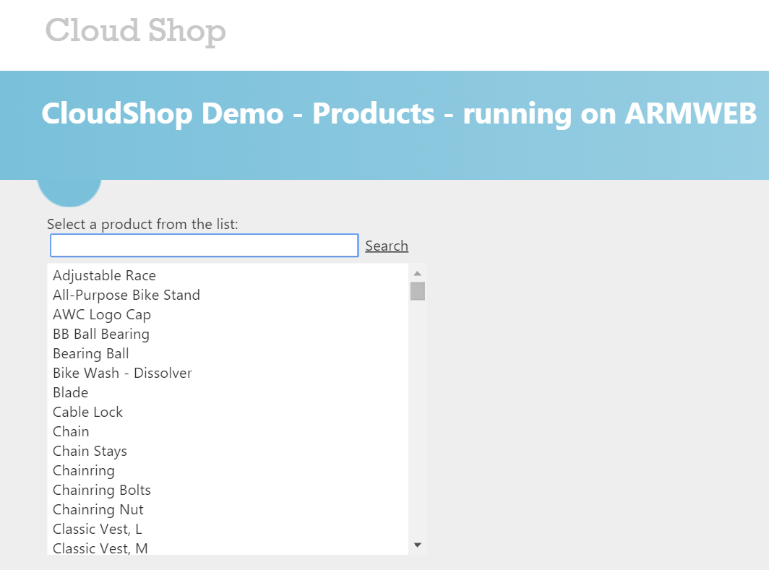

1. You should also verify your VMs are registered as DSC Nodes in your Automation Account. In the Azure portal, click **Resource groups > Automation_RG > Automation-Acct**. Then, click the **DSC Nodes** tile.   
   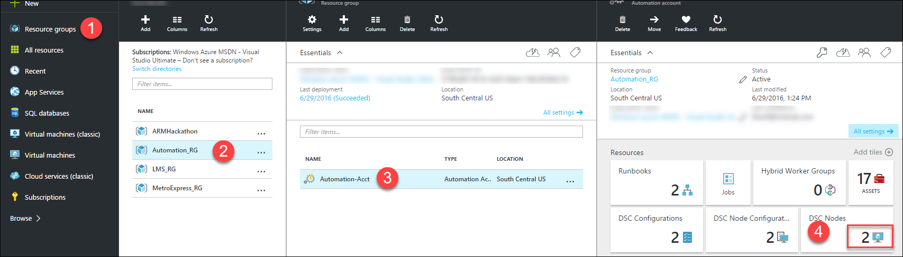

## Exercise 4: Lock down the environment

Duration: 15 minutes

In this exercise, you will deploy a network security group to restrict the network attack surface for the deployment.

#### Task 1: Restrict traffic to the web server

1. Add the following at the beginning of the JSON template as the first item under the **resources** node. This will deploy the network security group resource and add a rule. Therefore, the only port open on the Public IP is port 80.

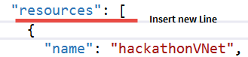

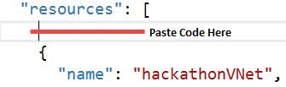

{

"apiVersion": "2016-03-30",

"type": "Microsoft.Network/networkSecurityGroups",

"name": "hackathonNetworkSecurityGroup",

"location": "[resourceGroup().location]",

"properties": {

"securityRules": [

{

"name": "webrule",

"properties": {

"description": "This rule allows traffic in on port 80",

"protocol": "Tcp",

"sourcePortRange": "*",

"destinationPortRange": "80",

"sourceAddressPrefix": "INTERNET",

"destinationAddressPrefix": "10.0.0.0/24",

"access": "Allow",

"priority": 100,

"direction": "Inbound"

}

}

]

}

},

1. Click the **hackathonVNet** resource to go to its configuration.

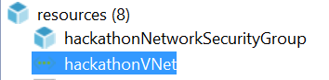

1. Associate the network security group with the **hackathonVnetSubnet1Name** subnet by adding a comma at the end of the **addressPrefix** block and pasting in the **networkSecurityGroup** reference.

"networkSecurityGroup": {

"id": "[resourceId('Microsoft.Network/networkSecurityGroups', 'hackathonNetworkSecurityGroup')]"

}

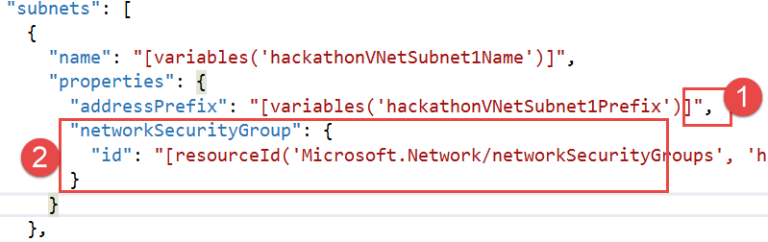

1. Update the virtual network to have a dependency on the network security group.
2. Click the **hackathonVNet** resource to view the configuration.

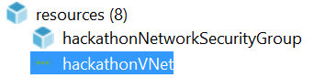

1. Change the **dependsOn** configuration to refer to the network security group.

"dependsOn": [

"[resourceId('Microsoft.Network/networkSecurityGroups', 'hackathonNetworkSecurityGroup')]"

],

1. Right-click the Visual Studio project, and select **Deploy** from the context menu followed by **New Deployment**. Click **Deploy** to update the existing deployment with the network security group.
2. In the Portal, browse to the ARMHackathon Resource Group and locate the newly added Network Security Group.



1. To validate the network security group is working:
   * Browse to the Public IP or DNS name of the web server. The site should load because traffic is allowed on port 80.
   * Connect to the **armweb** virtual machine by clicking **Connect** in the preview portal. This should fail because port 3389 is not allowed in.

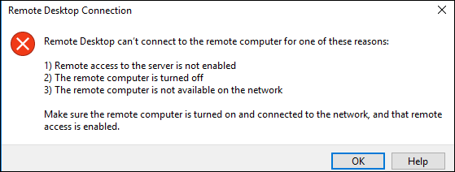

#### Task 2: Update the network security group to allow Windows Remote Desktop

1. Add a new rule to the network security group to allow in traffic on port 3389 Remote Desktop Protocol (RDP) by adding a comma at the end of the web rule and add the following code:

{

"name": "rdprule",

"properties": {

"description": "This rule allows traffic on port 3389 from the web",

"protocol": "Tcp",

"sourcePortRange": "*",

"destinationPortRange": "3389",

"sourceAddressPrefix": "INTERNET",

"destinationAddressPrefix": "10.0.0.0/24",

"access": "Allow",

"priority": 200,

"direction": "Inbound"

}

}

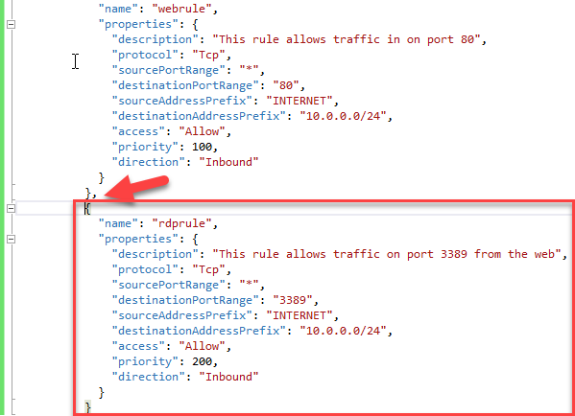

1. Perform another Deployment using Visual Studio to set the rule and test RDP connectivity again.
2. Open the Azure Preview Portal, and navigate to the resource group containing your deployment.
3. Click the **hackathonNetworkSecurityGroup** in the resources summary.
4. Examine the created rules.

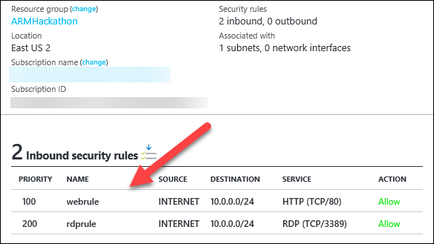

## Exercise 5: Scale out the deployment

Duration: 60 minutes

In this exercise, you will configure the template to scale out the web front-end using a scalable number of virtual machines and storage accounts. For this, you will use the load balancer and the scale sets feature.

#### Task 1: Parameterize and scale out the environment

1. Add the following variables to the end of the **variables** section of the **azuredeploy.json** file:

Tip: Do not forget to put a comma after the previous variables.

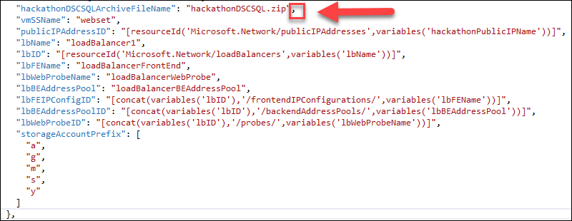

"vmSSName": "webset",

"publicIPAddressID": "[resourceId('Microsoft.Network/publicIPAddresses',variables('hackathonPublicIPName'))]",

"lbName": "loadBalancer1",

"lbID": "[resourceId('Microsoft.Network/loadBalancers',variables('lbName'))]",

"lbFEName": "loadBalancerFrontEnd",

"lbWebProbeName": "loadBalancerWebProbe",

"lbBEAddressPool": "loadBalancerBEAddressPool",

"lbFEIPConfigID": "[concat(variables('lbID'),'/frontendIPConfigurations/',variables('lbFEName'))]",

"lbBEAddressPoolID": "[concat(variables('lbID'),'/backendAddressPools/',variables('lbBEAddressPool'))]",

"lbWebProbeID": "[concat(variables('lbID'),'/probes/',variables('lbWebProbeName'))]",

"storageAccountPrefix": [

"a",

"g",

"m",

"s",

"y"

]

1. Add the following parameters to the end of the **parameters** section of the **azuredeploy.json** file (do not forget to add the comma after the last parameter).

"instanceCount": {

"type": "string",

"metadata": {

"description": "Number of VM instances"

}

},

"newStorageAccountSuffix": {

"type": "string",

"metadata": {

"description": "The Prefix for the names of the new storage accounts created"

}

}

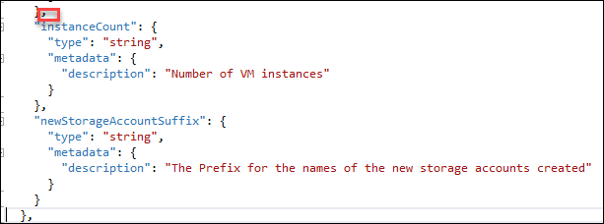

1. Add a new storage account resource using the copy function by pasting the following code as the first resource in the list.



{

"type": "Microsoft.Storage/storageAccounts",

"name": "[concat(variables('StorageAccountPrefix')[copyIndex()],parameters('newStorageAccountSuffix'))]",

"apiVersion": "2015-06-15",

"copy": {

"name": "storageLoop",

"count": 5

},

"location": "[resourceGroup().location]",

"properties": {

"accountType": "[parameters('hackStorageType')]"

}

},

Note: This code will create five storage accounts. The virtual machine scale set will distribute the virtual machine disks across the storage accounts to ensure the VMs do not run out of IO capacity.

1. Add a load balancer resource by pasting the following code as the first resource in the list.



Note: This code creates a load balancer resource that is listening on port 80.

{

"apiVersion": "2016-03-30",

"name": "[variables('lbName')]",

"type": "Microsoft.Network/loadBalancers",

"location": "[resourceGroup().location]",

"dependsOn": [

"[concat('Microsoft.Network/publicIPAddresses/',variables('hackathonPublicIPName'))]"

],

"properties": {

"frontendIPConfigurations": [

{

"name": "[variables('lbFEName')]",

"properties": {

"publicIPAddress": {

"id": "[variables('publicIPAddressID')]"

}

}

}

],

"backendAddressPools": [

{

"name": "[variables('lbBEAddressPool')]"

}

],

"loadBalancingRules": [

{

"name": "weblb",

"properties": {

"frontendIPConfiguration": {

"id": "[variables('lbFEIPConfigID')]"

},

"backendAddressPool": {

"id": "[variables('lbBEAddressPoolID')]"

},

"probe": {

"id": "[variables('lbWebProbeID')]"

},

"protocol": "Tcp",

"frontendPort": 80,

"backendPort": 80,

"enableFloatingIP": false

}

}

],

"probes": [

{

"name": "[variables('lbWebProbeName')]",

"properties": {

"protocol": "Http",

"port": 80,

"intervalInSeconds": 15,

"numberOfProbes": 5,

"requestPath": "/"

}

}

]

}

},

1. Add the virtual machine scale set to the **resources** section using the following configuration:

{

"type": "Microsoft.Compute/virtualMachineScaleSets",

"apiVersion": "2015-06-15",

"name": "[variables('vmSSName')]",

"location": "[resourceGroup().location]",

"tags": {

"vmsstag1": "Myriad"

},

"dependsOn": [

"[concat('Microsoft.Storage/storageAccounts/a',parameters('newStorageAccountSuffix'))]",

"[concat('Microsoft.Storage/storageAccounts/g',parameters('newStorageAccountSuffix'))]",

"[concat('Microsoft.Storage/storageAccounts/m',parameters('newStorageAccountSuffix'))]",

"[concat('Microsoft.Storage/storageAccounts/s',parameters('newStorageAccountSuffix'))]",

"[concat('Microsoft.Storage/storageAccounts/y',parameters('newStorageAccountSuffix'))]",

"[concat('Microsoft.Network/loadBalancers/',variables('lbName'))]",

"[concat('Microsoft.Network/virtualNetworks/','hackathonVnet')]"

],

"sku": {

"name": "Standard_DS1_V2",

"tier": "Standard",

"capacity": "[parameters('instanceCount')]"

},

"properties": {

"upgradePolicy": {

"mode": "Manual"

},

"virtualMachineProfile": {

"storageProfile": {

"osDisk": {

"vhdContainers": [

"[concat('https://a',parameters('newStorageAccountSuffix'),'.blob.core.windows.net/vmss')]",

"[concat('https://g',parameters('newStorageAccountSuffix'),'.blob.core.windows.net/vmss')]",

"[concat('https://m',parameters('newStorageAccountSuffix'),'.blob.core.windows.net/vmss')]",

"[concat('https://s',parameters('newStorageAccountSuffix'),'.blob.core.windows.net/vmss')]",

"[concat('https://y',parameters('newStorageAccountSuffix'),'.blob.core.windows.net/vmss')]"

],

"name": "vmssosdisk",

"caching": "ReadOnly",

"createOption": "FromImage"

},

"imageReference": {

"publisher": "[variables('hackathonVMImagePublisher')]",

"offer": "[variables('hackathonVMImageOffer')]",

"sku": "[parameters('hackathonVMWindowsOSVersion')]",

"version": "latest"

}

},

"osProfile": {

"computerNamePrefix": "[variables('vmSSName')]",

"adminUsername": "[parameters('hackathonVMAdminUserName')]",

"adminPassword": "[parameters('hackathonVMAdminPassword')]"

},

"networkProfile": {

"networkInterfaceConfigurations": [

{

"name": "nic1",

"properties": {

"primary": true,

"ipConfigurations": [

{

"name": "ip1",

"properties": {

"subnet": {

"id": "[variables('hackathonVMSubnetRef')]"

},

"loadBalancerBackendAddressPools": [

{ "id": "[variables('lbBEAddressPoolID')]" }

]

}

}

]

}

}

]

},

"extensionProfile": {

"extensions": [

{

"name": "hackathonDSC",

"properties": {

"publisher": "Microsoft.Powershell",

"type": "DSC",

"typeHandlerVersion": "2.19",

"autoUpgradeMinorVersion": true,

"protectedSettings": {

"Items": {

"registrationKeyPrivate": "[parameters('registrationKey')]"

}

},

"settings": {

"modulesUrl": "https://cloudworkshop.blob.core.windows.net/arm-hackathon/RegistrationMetaConfigV2.zip",

"configurationFunction": "RegistrationMetaConfigV2.ps1\\RegistrationMetaConfigV2",

"Properties": [

{

"Name": "RegistrationKey",

"Value": {

"UserName": "PLACEHOLDER_DONOTUSE",

"Password": "PrivateSettingsRef:registrationKeyPrivate"

},

"TypeName": "System.Management.Automation.PSCredential"

},

{

"Name": "RegistrationUrl",

"Value": "[parameters('registrationUrl')]",

"TypeName": "System.String"

},

{

"Name": "NodeConfigurationName",

"Value": "CloudShopWeb.WebServer",

"TypeName": "System.String"

},

{

"Name": "ConfigurationMode",

"Value": "[parameters('configurationMode')]",

"TypeName": "System.String"

},

{

"Name": "ConfigurationModeFrequencyMins",

"Value": "[parameters('configurationModeFrequencyMins')]",

"TypeName": "System.Int32"

},

{

"Name": "RefreshFrequencyMins",

"Value": "[parameters('refreshFrequencyMins')]",

"TypeName": "System.Int32"

},

{

"Name": "RebootNodeIfNeeded",

"Value": "[parameters('rebootNodeIfNeeded')]",

"TypeName": "System.Boolean"

},

{

"Name": "ActionAfterReboot",

"Value": "[parameters('actionAfterReboot')]",

"TypeName": "System.String"

},

{

"Name": "AllowModuleOverwrite",

"Value": "[parameters('allowModuleOverwrite')]",

"TypeName": "System.Boolean"

},

{

"Name": "Timestamp",

"Value": "[parameters('timestamp')]",

"TypeName": "System.String"

}

]

}

}

}

]

}

}

}

},

Note: This code creates a virtual machine scale sets resource that will create as many instances of the virtual machine as specified in the instanceCount parameter. The DSC extension will execute on each VM when it is created to configure the cloud shop web application. The scale set will distribute the VM disks across the previously created storage accounts.

1. Delete the existing **hackathonVM** and the **hackathonVMNic** resources by right-clicking each resource and clicking **Delete**.



This VM and NIC will be replaced by the VMs in the scale set.

1. Delete the existing deployment (to save on core quota) by opening the Azure portal (portal.azure.com) in your browser.
2. Click **Resource groups**.



1. Click the **ARMHackathon** resource group (or whatever you named your deployment).



1. Click **Delete**, and then, confirm by typing in the name of the resource group.



NOTE: Wait until the Resource Group has been deleted prior to moving on to the next step.

1. Create a **new deployment**, and choose a new **resource group**. Name the new resource group **ARMHackathonScaleSet**.



1. Choose any of the template parameters files, and click **Edit Parameters**.



1. Provide a unique value for the **hackathonPublicIPDnsName** and **newStorageAccountSuffix** parameters. Enter a value of **2** for the **instanceCount**. Click **Save** and **Deploy**.

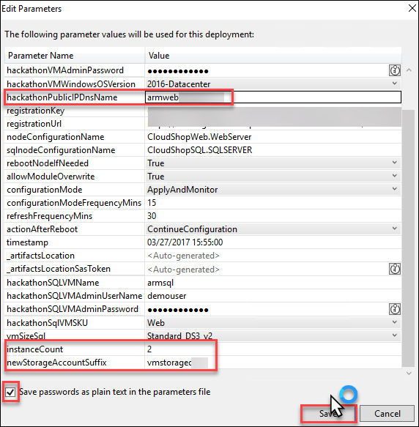

Note: The deployment may take 30 to 45 minutes to complete. If Visual Studio fails monitoring the solution with an error about the SAS Token expiring, you can open the resource group in the Portal, and you can monitor the deployment by clicking the link under the Last Deployment lab on the essentials pane.

1. Within the **Azure Management Portal**, open the **resource group**, and click the **hackathonPublicIP** resource.



1. Copy the **DNS name**, and navigate to it in a browser to validate the load balancer and the scale set are working. Click **Refresh** several times, and the page should flip from WEBSET-0 to WEBSET-1.

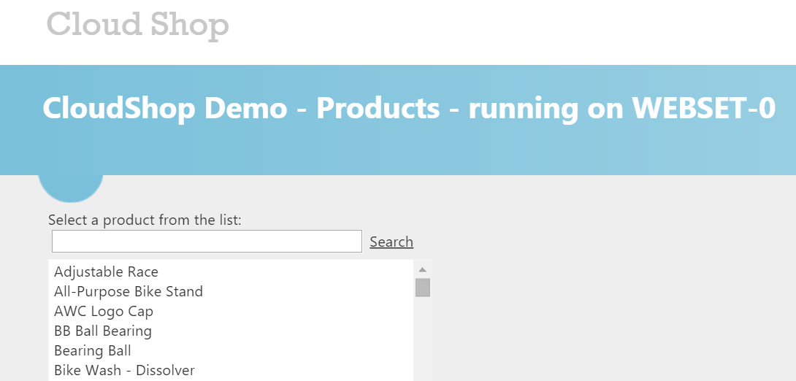

## After the hands-on lab

Duration: 10 minutes

#### Task 1: Delete the resource groups created

1. Within the Azure portal, click Resource Groups on the left navigation.
2. Delete each of the resource groups created in this lab by clicking them followed by clicking the Delete Resource Group button. You will need to confirm the name of the resource group to delete.

You should follow all steps provided *after* attending the hands-on lab.